**EXPERIMENT 9**

**VIEWS**

**Aim:**

* Create table student with attributes id, name and department.
* Display
* Create view and select
* Insert values
* Create view with check option
* Insert values and alter table

**Code:**

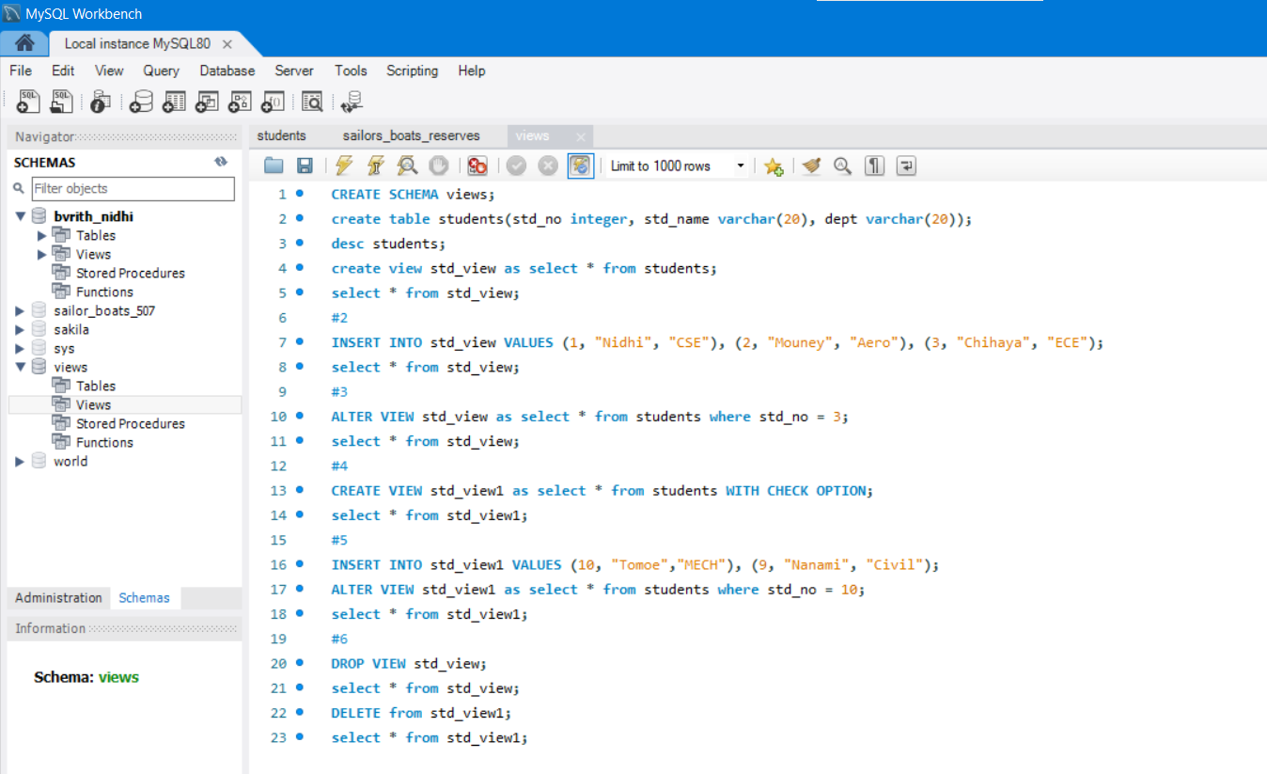

**Output:**

1. i)Create table students with stdno, name, dept 1. ii) Create view and select

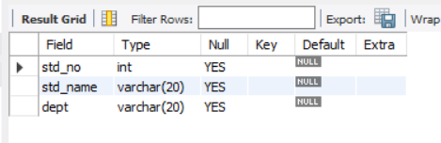 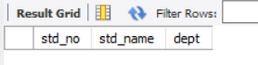

2. Insert values into std_view 3. Alter the view

 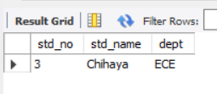

4. Create view with check option 5. Insert values and alter the view

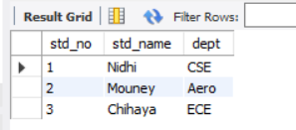 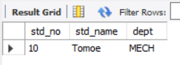

6. i)select std_view after drop std_view



6. ii) select std_view1 after delete from std_view1

